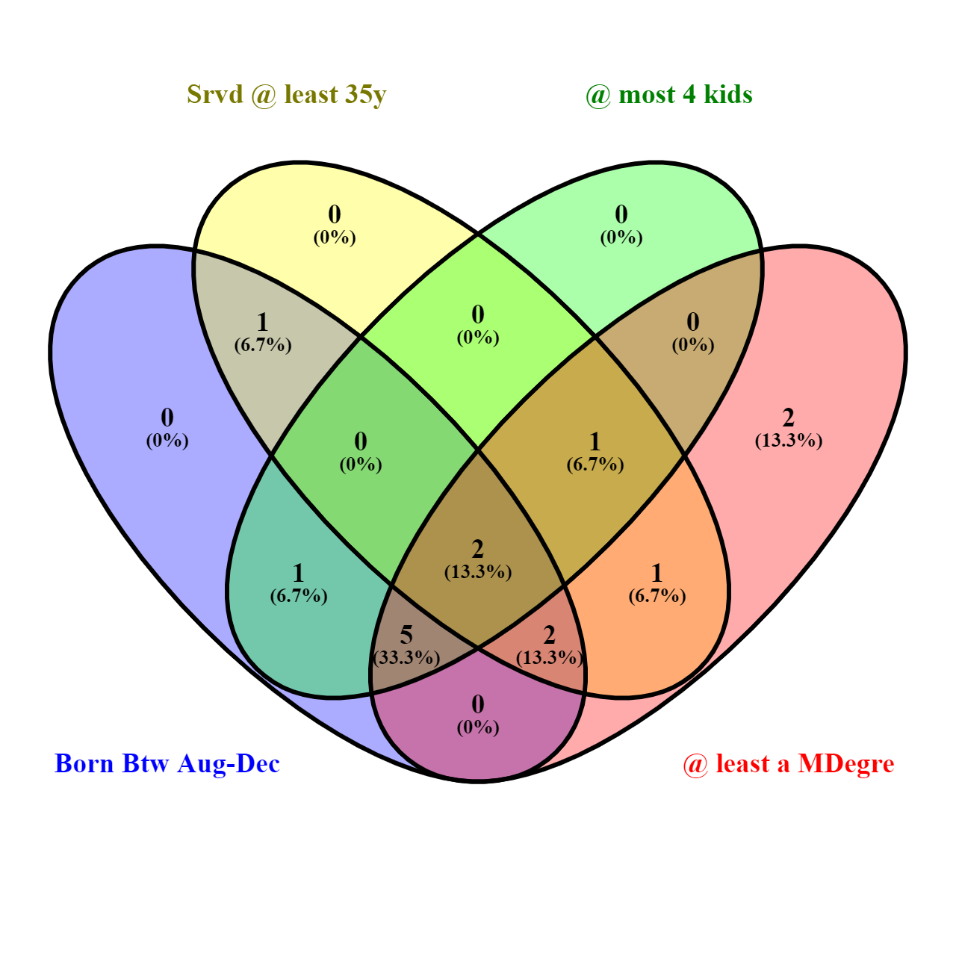

|  |  |  |  |  |
| --- | --- | --- | --- | --- |
| **APOSTLE** | **DATE OF BIRTH** | **NO. OF CHILDREN** | **HIGHEST DEGREE** | **APROX YRS OF SERVICE** |
| 1. RUSSELL MARION NELSON | 9TH SEPTEMBER 1924 | 10 | DOCTORATE DEGREE | Over 50yrs |
| 1. DALLIN HARRIS OAKS | 12TH AUGUST 1932 | 6 | JURISPRUDENCE DOCTORATE DEGREE | Over 50yrs |
| 1. MELVIN RUSSELL BALLARD | 8TH OCTOBER 1928 | 6 | BACHELORS DEGREE | Over 45yrs |
| 1. HENRY BENNION EYRING | 31ST MAY 1933 | 7 | DOCTORATE DEGREE | Over 45yrs |
| 1. JEFFERY ROY HOLLAND | 3RD DECEMBER 1940 | 3 | DOCTORATE DEGREE | Over 40yrs |
| 1. DIETER FRIEDRICH UTCHDORF | 6TH NOVEMBER 1940 | 2 | MASTERS DEGREE | Over 35yrs |
| 1. DAVID ALLAN BEDNAR | 15TH JUNE 1952 | 3 | DOCTORATE DEGREE | Over 35yrs |
| 1. QUENTIN LAMAR COOK | 8TH SEPTEMBER 1940 | 3 | JURISPRUDENCE DOCTORATE DEGREE | Over 30yrs |
| 1. DAVID TODD CHRISTIPHERSON | 24TH JANUARY 1945 | 5 | JURISPRUDENCE DOCTORATE DEGREE | Over 30yrs |
| 1. NEIL LINDEN ANDERSEN | 9TH AUGUST 1951 | 4 | MASTERS DEGREE | Over 30yrs |
| 1. RONALD ANDERSON RASBAND | 6TH FEBRUARY 1951 | 5 | MASTERS DEGREE | Over 30yrs |
| 1. GARY EVAN STEVENSON | 6TH AUGUST 1955 | 4 | BACHELORS DEGREE | Over 25yrs |
| 1. DALE GUNNAR RENLUND | 13TH NOVEMBER 1952 | 1 | MASTERS DEGREE | Over 25yrs |
| 1. GERRIT WALTER GONG | 23RD DECEMBER 1953 | 4 | DOCTORATE DEGREE | Over 25yrs |
| 1. ULISSES SOARES | 2ND OCTOBER 1958 | 3 | MASTERS DEGREE | Over 25yrs |